PYTHON ACTIVITY-BASED LEARNING
Case Study 2: Examination Result and Grace-Mark Validation
Name: Ganji Sreevalli
Roll Number: 26000900
Branch: CSE (AIML)
Subject: Python Programming
1. Problem Statement
To develop a Python program that accepts marks for five subjects, checks the pass criteria, applies grace marks when eligible, and displays the total marks, percentage, and final examination result.
2. Objectives
- To accept marks for multiple subjects.
- To validate marks entered by the user.
- To identify subjects in which the student has failed.
- To apply grace marks according to the defined rules.
- To calculate total marks and percentage.
- To display the final result as PASS or FAIL.
3. Assumptions
- The student has five subjects.
- Each subject is out of 100 marks.
- The minimum passing mark is 35 in each subject.
- Grace marks can be used if exactly one subject is failed.
- The student must be within five marks of the passing mark.
- The maximum grace marks available are five in total.
- These rules are assumptions for this learning exercise and are not official examination regulations.
4. Algorithm
- Start the program.
- Set the passing mark to 35 and maximum grace marks to 5.
- Accept marks for five subjects.
- Validate that each mark is between 0 and 100.
- Identify the subjects in which the student has failed.
- If exactly one subject is failed and the marks needed are within the grace-mark limit, add the required grace marks.
- Calculate the total marks and percentage.
- Display the marks, grace marks used, total, and percentage.
- Display PASS if all subjects meet the passing mark; otherwise, display FAIL.
- Stop the program.
5. Flowchart
6. Pseudocode
START
Set PASS_MARK = 35
Set MAX_GRACE_MARKS = 5
Input marks for five subjects
Validate each mark

Find failed subjects
Set grace_used = 0

IF exactly one subject is failed:
Calculate marks needed
IF marks needed <= MAX_GRACE_MARKS:
Add grace marks to that subject
Update grace_used

Calculate total marks
Calculate percentage

Display marks and grace marks used
Display total and percentage

IF all subjects have at least PASS_MARK:
Display PASS
ELSE:
Display FAIL

STOP
7. Python Source Code

# Case Study 2: Examination Result and Grace-Mark Validation

PASS_MARK = 35
MAX_GRACE_MARKS = 5
NUMBER_OF_SUBJECTS = 5

marks = []

print("===== EXAMINATION RESULT SYSTEM =====")

# Input marks for five subjects
for i in range(NUMBER_OF_SUBJECTS):
while True:
try:
mark = int(input(f"Enter marks for Subject {i + 1} (0-100): "))

if 0 <= mark <= 100:
marks.append(mark)
break
else:
print("Please enter marks between 0 and 100.")

except ValueError:
print("Invalid input. Please enter a whole number.")

# Find subjects in which the student failed
failed_subjects = []

for i in range(NUMBER_OF_SUBJECTS):
if marks[i] < PASS_MARK:
failed_subjects.append(i)

grace_used = 0

# Apply grace marks only if exactly one subject was failed
if len(failed_subjects) == 1:
index = failed_subjects[0]
marks_needed = PASS_MARK - marks[index]

if marks_needed <= MAX_GRACE_MARKS:
marks[index] = PASS_MARK
grace_used = marks_needed

# Calculate total and percentage after grace marks
total = sum(marks)
percentage = total / NUMBER_OF_SUBJECTS

# Display the result
print("\n========== RESULT ==========")

for i in range(NUMBER_OF_SUBJECTS):
print(f"Subject {i + 1}: {marks[i]}")

print("Grace Marks Used:", grace_used)
print("Total Marks:", total, "/", NUMBER_OF_SUBJECTS * 100)
print("Percentage:", round(percentage, 2), "%")

if all(mark >= PASS_MARK for mark in marks):
print("Final Result: PASS")
else:
print("Final Result: FAIL")

print("============================")

8. Test Cases
Test | Subject 1 | Subject 2 | Subject 3 | Subject 4 | Subject 5 | Expected result
1 | 80 | 70 | 32 | 65 | 90 | PASS with 3 grace marks
2 | 80 | 70 | 25 | 65 | 90 | FAIL
3 | 80 | 70 | 40 | 65 | 90 | PASS without grace marks
4 | 80 | 70 | 32 | 30 | 90 | FAIL
5 | 100 | 100 | 100 | 100 | 100 | PASS without grace marks
9. Output Screenshots
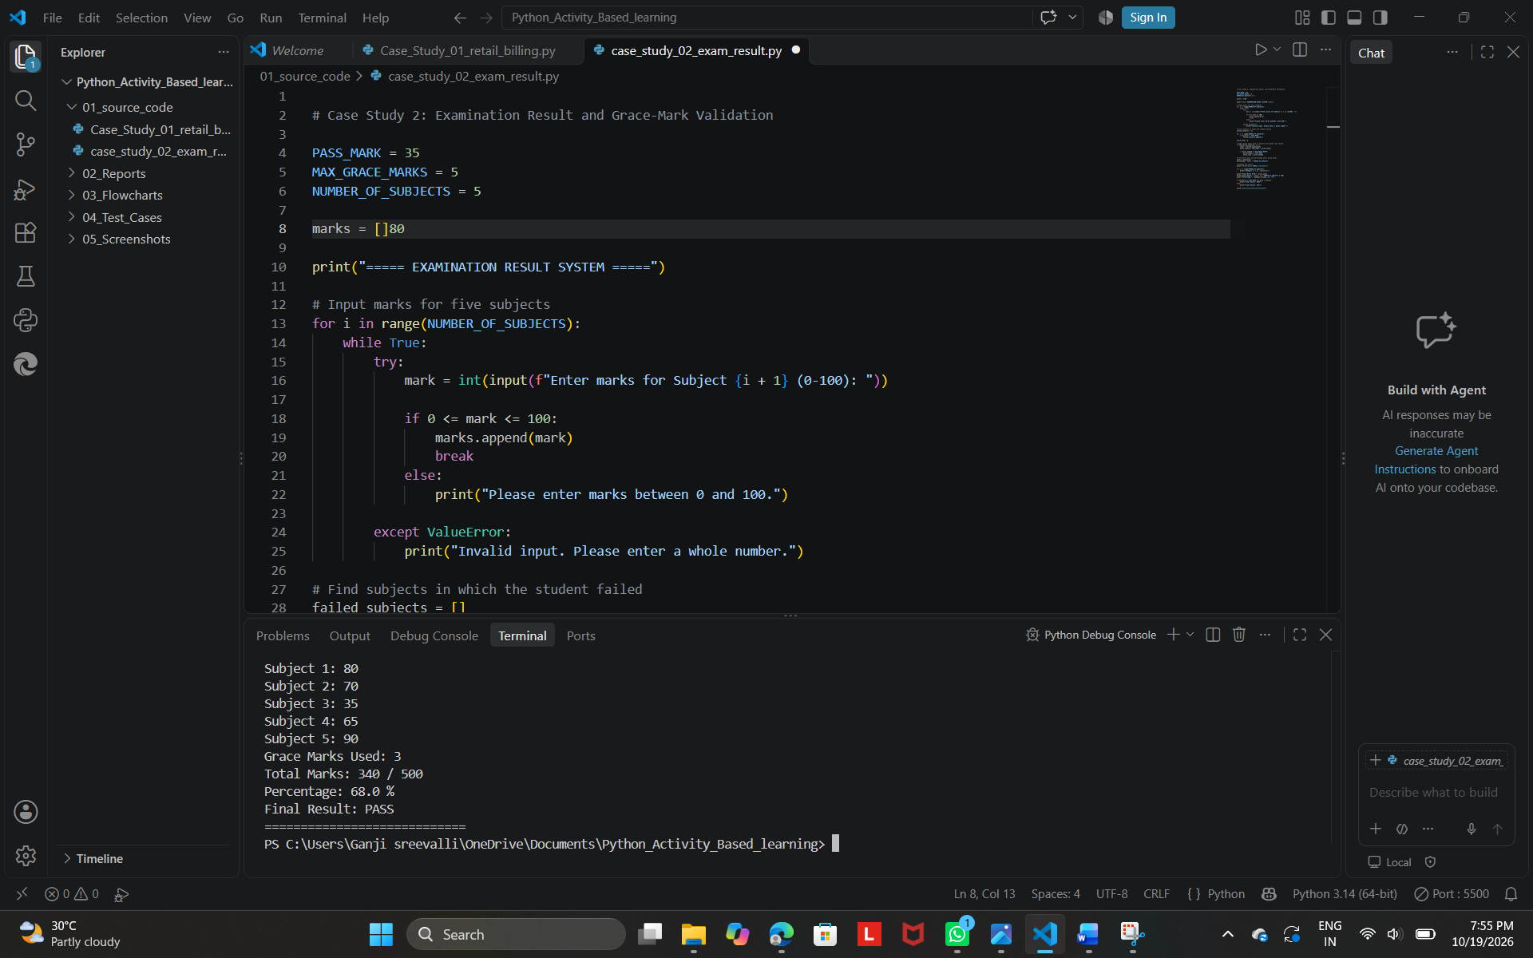
10. Conclusion
The Examination Result and Grace-Mark Validation program demonstrates how Python can be used to accept and validate student marks, identify failed subjects, apply defined grace-mark rules, and calculate total marks and percentage. It uses variables, lists, loops, conditional statements, exception handling, and arithmetic operations.

